Macrosystems EDDIE:

Teleconnections

**Student Handout**

# Learning Objectives:

By the end of this module, you will be able to:

* Understand the concepts of macrosystems ecology and teleconnections, and how different ecological processes can interact at local, regional, and global scales.
* Set up and run ecosystem models to simulate lake temperatures and ice cover in multiple lakes (Activity A).
* Test the effects of teleconnected climate scenarios on the different lake models, and examine how local characteristics modify global-scale climate forcing effects on lake temperatures and ice cover (Activity B).
* Compare the role of teleconnections in driving lake temperatures and ice cover across multiple lakes in different regions (Activity C).
* Predict how lake temperatures and ice cover may respond to changes in the timing and intensity of global-scale meteorological phenomena (Activity C).

# Why macrosystems ecology?

***Macrosystems ecology*** is the study of ecological dynamics at multiple interacting spatial and temporal scales (e.g., Heffernan et al. 2014). Macrosystems ecology recently emerged as a new sub-discipline of ecology to study ecosystems and ecological communities around the globe that are changing at an unprecedented rate because of human activities (IPCC 2013). The responses of ecosystems and communities are complex, non-linear, and driven by feedbacks across local, regional, and global scales (Heffernan et al. 2014). These characteristics necessitate novel approaches for making predictions about how systems may change across time and space. Consequently, macrosystems ecologists are increasingly combining large datasets of sensor observations with simulation models of ecological phenomena to predict how changes in climate, land use, and other factors may affect the structure and function of communities and ecosystems (Weathers et al. 2016).

## A macrosystems approach to lake ecology

Using a macrosystems approach is necessary for studying environmental challenges that are driven by multiple factors across space and over time. In freshwater lakes and reservoirs worldwide, water temperatures are changing in response to local, regional, and global drivers (O’Reilly et al. 2015). For example, some lakes are experiencing changes in water temperature due to local-scale changes in land use (e.g., increasing impervious surface in a catchment can result in warmer inflow streams entering a lake) and regional-scale changes due to altered weather patterns (e.g., climate change is increasing air temperatures in some regions, resulting in warmer water temperatures). Lake temperatures and ice cover can also be affected by global drivers, such as the El Niño/Southern Oscillation (ENSO). ENSO is an example of a climate **teleconnection**, or a phenomenon that links remote regions via cause and effect relationships. ENSO periods have warmer ocean surface temperatures in the tropical Pacific Ocean, resulting in altered atmospheric circulation, air temperature, and precipitation patterns worldwide, but the global effect of ENSO on a particular lake is mediated by local and regional dynamics.

The theme of this module is studying the effect of global ENSO ***teleconnections*** on lake temperatures and ice cover. In this module, you will work with a partner to study how global circulation patterns interact with local and regional characteristics to affect lake temperatures and ice cover in different lakes and reservoirs across the United States.

# Module overview:

1. Introduction to Macrosystems Ecology: pre-readings and PowerPoint in class
2. Download and set up R software and module files on your computer
3. Activity A: Run and explore a whole-lake simulation model in R for your focal lake
4. Activity B: Use long-term data to calculate the effect of a “typical” and a “strong” El Niño scenario on your focal lake’s regional meteorology, generate hypotheses about how El Niño will affect your lake, and examine how your focal lake responds.
5. Activity C: Compare the effects of the three model scenarios on your focal lake’s temperatures and ice cover. Then compare how lakes across the continent responded to the El Niño scenarios, and make predictions about continental-scale variability in lake teleconnections.

# Optional pre-class readings and video:

* Heffernan, J.B., et al. 2014. "Macrosystems ecology: understanding ecological patterns and processes at continental scales." Frontiers in Ecology and the Environment 12(1): 5-14.
* National Oceanic and Atmospheric Administration "El Niño-Southern Oscillation" website: https://www.climate.gov/enso

# Today’s focal question:

## *How do global ENSO teleconnections* ***interact*** *with local and regional characteristics to affect lake temperatures and ice cover?*

To address this question, we will use an open-source lake simulation model called GLM (General Lake Model; Hipsey et al. 2014). The GLM model requires three input files: (1) a meteorological driver file that contains multiple weather variables (including air temperature, solar radiation, wind, and precipitation), (2) an inflow driver file that contains inflow volume and water temperature for the streams entering the lake (*if* there are any surface inflows for your lake!), and (3) an outflow driver file that contains outflow volume, for lakes that have surface outflows. GLM also has a configuration file, or ‘master script’ called the nml file (named glm2.nml) that give basic information about the lake (e.g., maximum depth, latitude, lake name, etc.) and instructions for GLM as to how the model should be run. These instructions include the simulation start and end dates and times, the time step of the model, and the names of the meteorological and inflow data files. From both the input and configuration files, the model will simulate a range of variables, including ice cover and lake temperatures at many depths, over time. For more information about GLM, see: <http://aed.see.uwa.edu.au/research/models/GLM>.

We will be running multiple GLM models configured for different lakes to compare how lakes across the United States respond to El Niño teleconnections. Most of our study lakes are part of NEON, the National Ecological Observatory Network ([www.neonscience.org](http://www.neonscience.org)), which is a continental-scale ecological network that is collecting high-frequency data at sites across the United States to understand how ecosystems are changing. This module also contains lakes that are part of GLEON, the Global Lake Ecological Observatory Network ([gleon.org](http://www.gleon.org)), an organization of scientists who collect and share high-resolution sensor data to study how lakes are changing in response to human activities.

These models were set up using high-frequency datasets from NEON, GLEON, NOAA (U.S. National Oceanic and Atmospheric Administration), and NASA (U.S. National Aeronautics and Space Administration). We made some changes to the lake models to simplify the surface water hydrology for this module.

# Setting up R software and files:

If you have not already downloaded R and RStudio, you will need to complete that step first. You can use the file ‘R You Ready for EDDIE’ for help. Once you have R and RStudio installed, all the information you need for the modeling activities is embedded into the R scripts within the zipped module project folders for RStudio. First, download the zipped folder, then unzip the folder and open the script file (R_Script.R). Read through the annotation for each step so that you understand what is happening in each of the lines of code that you are running.

# References:

Hipsey, M. R., L. C. Bruce, and D. P. Hamilton. 2014. GLM - General Lake Model: Model overview and user information. AED Report #26, The University of Western Australia, Perth, Australia. 42 pp.

IPCC. 2013. Climate Change 2013: The Physical Science Basis. Contribution of Working Group I to the Fifth Assessment Report of the Intergovernmental Panel on Climate Change. (T. F. Stocker, D. Qin, G.-K. Plattner, M. Tignor, S. K. Allen, J. Boschung, A. Nauels, Y. Xia, V. Bex, and P. M. Midgley, Eds.). Cambridge University Press, New York, NY.

O’ Reilly, C. M., R. J. Rowley, P. Schneider, J. D. Lenters, P. B. McIntyre, and B. M. Kraemer. 2015. Rapid and highly variable warming of lake surface waters around the globe. Geophysical Research Letters 42:10,773-10,781.

Weathers, K. C., P. M. Groffman, E. Van Dolah, E. Bernhardt, N. B. Grimm, K. McMahon, J. Schimel, M. Paolisso, R. Maranger, S. Baer, K. Brauman, and E. Hinckley. 2016. Frontiers in Ecosystem Ecology from a Community Perspective: The Future is Boundless and Bright. Ecosystems 19:753–770.

**As you go through the module, you’ll answer the questions below and turn in your answers at the end of the activity for credit.**

# Name: Focal Lake:

# Think about it!

With a partner, use the maps below to answer the following questions:

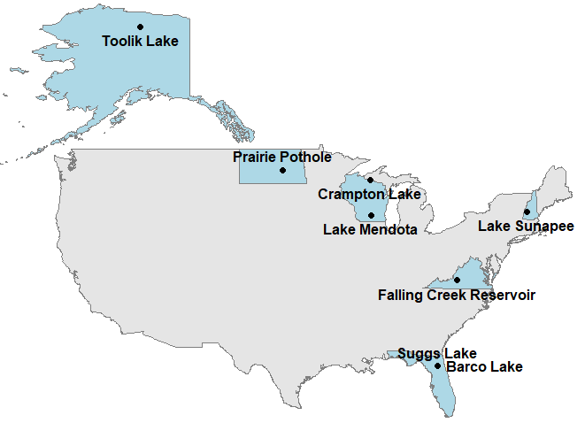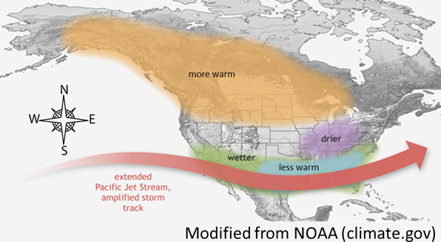

1. Which lake’s surface water temperatures do you hypothesize will show the largest warming response to a typical El Niño event? The smallest warming response? Why?
2. Which lake’s ice cover do you hypothesize will change the most in response to a typical El Niño event? Would ice cover be higher or lower during the El Niño event? Why?

# Activity A: Plot lake temperatures and ice cover in your model lake

1. Make sure you have **unzipped** the ‘teleconnections’ folder to your **Desktop**. With a partner, use the latitude and longitude from the Lake Characteristics file in your teleconnections folder and a web mapping tool (e.g., Google Maps in “Satellite” mode) to look up the location of your focal lake. Where is the lake located? When looking at the satellite version of the map, how would you describe the land use in the lake’s watershed?
2. With your partner, set up the R packages and GLM files on your computer for your model lake (Objective 1 in the R script). To run your model, you first have to identify your “sim_folder” to set your working directory—read through the R script notes to find out how. Once you have determined your sim_folder location, write it here (and don’t forget to also change it in the R script!):

sim_folder <- '/Users/___________________/Desktop/teleconnections/Lakes/_________________'

1. Run the GLM model for a baseline, non-El Niño year (2013) and explore the output for lake temperatures and ice cover (Objective 2).
   1. Look at the color gradient scale on the temperature heat map: Does your lake exhibit stratification? When during the year is the lake surface temperature warmest? What is the value of the maximum temperature on the color scale? The minimum temperature?
   2. Does your lake have ice cover? How does ice cover change over the model time period?

# Activity B: Calculate a “typical” and a “strong” El Niño annual scenario, generate hypotheses, and model how the lake responds

1. Working with your partner, you will first analyze long-term mean annual air temperature data for your lake (the annual_temp data file in the R script) using linear regression to estimate the effect of past El Niño events on air temperatures at your lake’s location (Objective 3). Luckily, a few lines of code in R make these calculations easy! Write down the following values you calculate for your lake:
   1. What is the estimated mean annual air temperature based on linear regression for your lake in 2013, the year of our model simulation? Why does this differ from the observed mean annual air temperature in 2013 from the annual_temp file?
   2. What is your calculated annual temperature offset for “typical” El Niño years relative to neutral, non-El Niño years?
   3. Develop a hypothesis about how this typical El Niño scenario may affect lake temperatures and ice cover in your model lake: Given the change in air temperatures, what changes in lake surface temperatures and ice cover do you expect to observe in your lake during El Niño years? Why?
2. After you’ve calculated your typical El Niño offset, you will use R commands to create the new meteorological driver file for GLM, which you will need to run the model for our typical El Niño scenario. Luckily, you don’t even have to open Excel! After you’ve created the new driver file, make sure you change your glm2.nml file so that the meteo_fl entry is the name of your new .csv file (met_hourly_scenario2.csv), not met_hourly.csv (**don’t forget to save your changes!**). Now run the model to see how lake temperatures and ice cover change under a typical El Niño scenario!
3. Plot the model output to help answer these questions:
4. Does the model output support or contradict the hypotheses you listed in 6c?
5. How does your lake’s vertical temperature profile (heatmap) compare to the baseline (non-El Niño year) model? Have the maximum and minimum values on the heatmap changed, and if so, by how much?
6. Now, you’ll use the long-term data to find the El Niño year in the long-term dataset that had the warmest air temperature, and use that year to estimate a “strong” El Niño scenario for your model lake (Objective 4).
7. Based on your long-term air temperature data plot and the “offsets” data file, which El Niño year had the highest mean annual air temperature? What was the average temperature (°C) that year?
8. What is the estimated air temperature offset (°C) for that strong El Niño year relative to neutral, non-El Niño years?
9. Develop hypotheses about how your lake may respond to the “strong” El Niño scenario. Given the change in air temperatures, what changes in lake temperatures and ice cover do you expect to observe in your lake during a strong El Niño year? Why?
10. As before, you will use R commands to create another new meteorological driver file for GLM. Once again, make sure you change your glm2.nml file so that the meteo_fl entry is the name of your new .csv file (met_hourly_scenario3.csv), and **don’t forget to save your changes** before you run the model! Now run the model to see how lake temperatures changed under a “strong” El Niño scenario!
11. Based on heatmaps of your lake temperatures, does the model output support or contradict the hypotheses you listed in 9c? How do the temperature profile heatmaps for the “strong” El Niño differ from the baseline and typical El Niño model scenarios? Have the maximum and minimum values on the heatmap changed?
12. What changes do you observe in ice cover in your “strong” El Nino compared to the baseline simulation?

# Activity C: Compare lake responses to El Niño scenarios, and examine how local and regional characteristics mediate lake responses to global climate teleconnections

1. Create line plots (Objective 5) for both lake temperatures and ice cover across your three scenarios (a non-El Niño year, a “typical” El Niño year and a “strong” El Niño year). Make sure you adjust the plot y-limits (ylim values) to effectively show your lake’s data!
   1. How much did your lake surface and bottom water temperatures change across the three scenarios?
   2. How much did ice cover change across the three scenarios, in terms of the number of days with ice?
   3. Using the map on the first page of your handout, do your line plots support the predictions in the NOAA figure (the right panel on page 4) for your focal lake’s location? Why or why not?
   4. Open the Lake_Characteristics.xlsx file in the teleconnections folder on your Desktop, and look at the characteristics of your lake. Do any of these characteristics help you interpret your lake response to the different El Niño scenarios? How?

13) Compare your model output and line plots from your focal lake with your classmates.

1. Based on the model output across all of the different lakes, which lake exhibited the greatest change in surface and bottom water lake temperatures? Ice cover?
2. Did surface and bottom water temperatures respond differently to El Niño forcing? If so, how?
3. Does your answer to 13a support or contradict the hypotheses you provided in response to questions 1 and 2? Why or why not?

14) Use your understanding of the model output to think about ENSO teleconnections more broadly:

a. Our scenarios only examined the effects of altered air temperature due to El Niño, but we know that other meteorological drivers are also affected by ENSO teleconnections. How do you predict your focal lake would respond if precipitation changes were also included in the El Niño scenarios?

b. We did not model any lakes in the central or western regions of the U.S. How do you predict that lakes in these regions might respond to El Niño forcing? (Hint: see the NOAA El Niño map!)

15) Some lakes exhibited larger changes in lake temperatures and ice cover than others in response to the El Niño scenarios, but generally all the model lakes exhibited some changes in the same direction. What does this tell us about how regional context mediates global teleconnections?